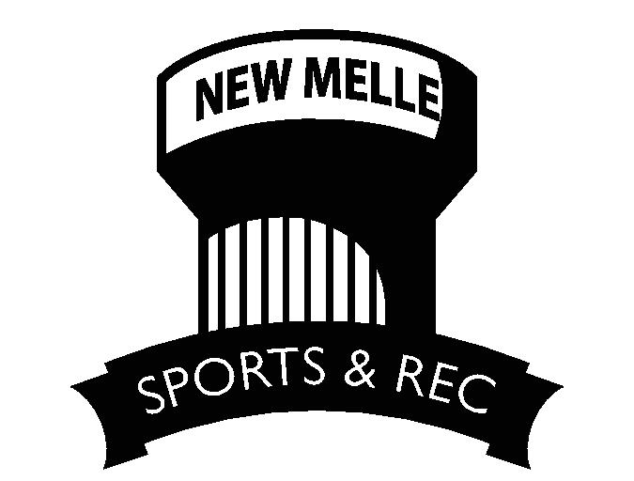

NMSR Board of Directors Application Form

Thank you for your interest in joining the New Melle Sports and Recreation Board of Directors! Use this form to provide useful information about yourself, to ensure the best match between you and our non-profit organization. The following information will be shared with our current Board of Directors.

Your Name:__________________________________________________________________

Your Home Phone Number: ______________________ Cell Number: ____________________

Your Address: _________________________________________________________________

____________________________________________________________________________

Your Email Address (please write it carefully):

____________________________________________________________________________

Briefly describe why you would like to join our Board of Directors:

_____________________________________________________________________________

_____________________________________________________________________________

_____________________________________________________________________________

_____________________________________________________________________________

Your current organizational affiliations (names of the organization and your role(s)):

1. ___________________________________________________________________________

2. ____________________________________________________________________________

3. ____________________________________________________________________________

4. ____________________________________________________________________________

Which of your skills would you like to utilize on the Board? Check those that apply:

- Board development  - Strategic planning  - Staffing / HR  - Program development | - Financial management  - Fundraising  - Evaluation  - Community networking | - Training  - Marketing  - Volunteer management  - Facilities management
Which of the following programs/committees would you be willing to help with? Check those that apply:

- Football  - Baseball/Softball/T-Ball  - Kickball  - Sand Volleyball  - Festival | - Cheer  - Dance  - Cornhole  - Soccer  - Fundraising/Sponsors | - Grounds  - Concessions  - Maintenance  - Pickleball  - Golf

Other skill(s) of yours that you would like to utilize? ___________________________________

______________________________________________________________________________

______________________________________________________________________________

What would you like to get for yourself out of your participation on the Board, e.g., what types of experiences, skills to develop, interests to cultivate for you, etc.? _____________________________________________________________________________

_____________________________________________________________________________

_____________________________________________________________________________

_____________________________________________________________________________

If you join the Board, you agree that you can provide at least 1-2 hours a month in attendance to Board and Committee meetings on the second Tuesday of every month, and that you do not have any conflict-of-interest in participating on the Board. You also agree to complete a background check provided by NMSR.

Your Signature: _____________________________________ Date: ______________________

If you are not selected as a member of the Board, or if you decide not to join, would you like to be a volunteer to assist our organization in various ways that match your skills and interests?
- Yes | - No | - Perhaps

